MED D - Test Claim - Calculating Quantity of Inhalers and Nasal Sprays

Definition | - Inhaler - A portable device for administering a drug which is to be breathed in, used for relieving asthma and other bronchial or nasal congestion.  - Nasal Spray - A liquid medication that can be atomized and inhaled into or through the nose.  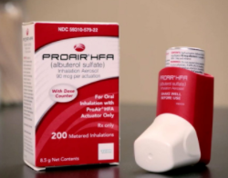  Be careful not to confuse an Inhaler or Nasal Spray with a Nebulizer Solution.
Instructions for Running a Test Claim | How many total puffs or sprays are used per day?  What day supply is needed?  Nasal Spray Example: The caller states they use 1 spray in each nostril daily. This would equal a total of 2 sprays per day.  
Additional Notes | For assistance in determining which NDC, package size, etc. will be used for a Price Estimate for a prescription, contact Clinical Care Services. For example, Asmanex INH (all strengths) and Zomig NSL SPR 6’s (all strengths) have specific package & NDC requirements based on dosage being prescribed.
What if Test Claim Rejects | Review the rejection code to determine what caused the rejection. Once the rejection code is identified, access the proper work instruction and job aids in theSource to help you resolve the issue.

Example
Ventolin
INH 18gm

Directions: Use 2 puffs 4 times daily

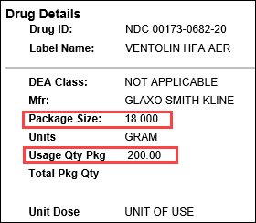 |  |  | 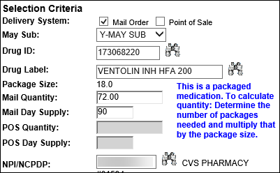
Calculation
Puffs per Day | X | Days |  | = | Puffs Needed
8 | X | 90 |  | = | 720
Puffs Needed | ÷ | Usage Quantity Package  (from PeopleSafe) |  | = | Total Number of Inhalers
720 | ÷ | 200 |  | = | 3.6 (Round up to 4)
Total Number of Inhalers | X | Package Size  (from PeopleSafe) |  | = | Test Claim Quantity
4 | X | 18 gm |  | = | 72

Example
QNasl 80mcg

Directions: Use 2 sprays each nostril daily



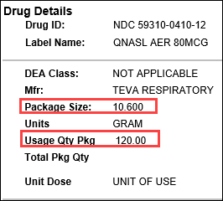 |  |  | 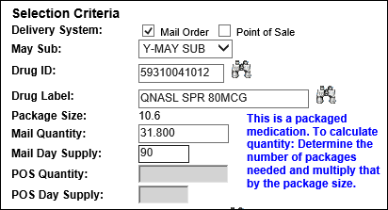
Calculation
Sprays per Day | X | Days |  | = | Sprays Needed
4 | X | 90 |  | = | 360
Sprays Needed | ÷ | Usage Quantity Package  (from PeopleSafe) |  | = | Total Number of Nasal Sprays
360 | ÷ | 120 |  | = | 3
Total Number of Nasal Sprays | X | Package Size  (from PeopleSafe) |  | = | Test Claim Quantity
3 | X | 10.6 gm |  | = | 31.8

Top of the Document

Related Documents
MED D - Test Claim Index
Calculating Quantities for Packaged Medication

Parent SOP: CALL-0049: Customer Care Internal and External Call Handling
Abbreviations / Definitions: Customer Care Abbreviations, Definitions, and Terms

Top of the Document

Not To Be Reproduced Or Disclosed to Others Without Prior Written Approval
ELECTRONIC DATA = OFFICIAL VERSION – PAPER COPY – INFORMATIONAL ONLY

